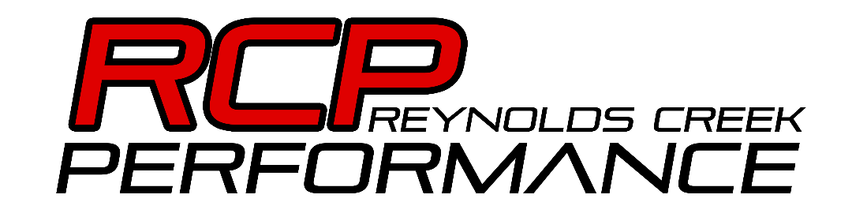

Pre-Tune Checklist
- Electrical components in working condition.
  - Battery and alternator in good shape.
  - Wiring clean (No hacked up wiring, wires routed away from heat sources and moving parts, no short or open circuits.)
  - All sensors installed, working and plugged in.
- Engine, transmission and drivetrain must be checked BEFORE tuning.
  - No leaks (oil, coolant, transmission, etc.)
  - All fluids checked and full.
  - Good compression on all cylinders.
  - No abnormal noises from engine or drivetrain.
  - Valvetrain components must match camshaft (springs, pushrods, etc.)
  - Plugs fresh and ignition system working.
  - No exhaust leaks or vacuum/boost leaks.
  - No CEL codes unless they are tuning related.
  - Clutch in good condition and rated for your power level.
  - No open headers.
- Fuel system properly sized and working.
  - Fuel pressure verified.
  - Injectors must be accepted by me, ahead of time. I will not accept injectors without good flow data.
  - Injectors sized to feed your power level. Stock 25lb injectors will not feed your cammed 6.0L.
  - No leaks.
  - Regulator, pump, and lines properly sized.
  - Fuel filter must be fresh.
  - Full tank of the fuel you plan to run, high compression engines will need more octane.
- Chassis in good condition.
  - All bolts tightened.
  - Brakes in working condition.
  - Tires inflated and not worn out/dry rotted.
  - Must be in good alignment.
Repair and diagnostics of any issues will be at the rate of $75 per hour.
All appointments for new customers will require a $50 deposit.
No refunds will be made for missed appointments.

